**SPACE INVADER**

In order to make this game fully functional in your PC/Laptop, first follow a few steps given below:-

1) Install PyCharm - I've used Community version.

Link to download PyCharm - **https://www.jetbrains.com/pycharm/**

2) Install Python version 3.7 or above - I've used Python version 3.7

Link to download Python - **https://www.python.org/**

3) After Installing both of the above , Open PyCharm & Go-to :=

i) File & Create New Project

ii) Name your Project

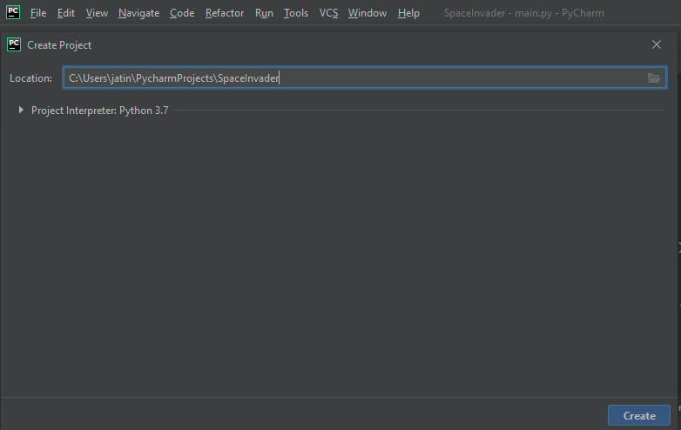

iii) After creating project , Right Click on the **SpaceInvader** folder , Click on New & Click on Python File.

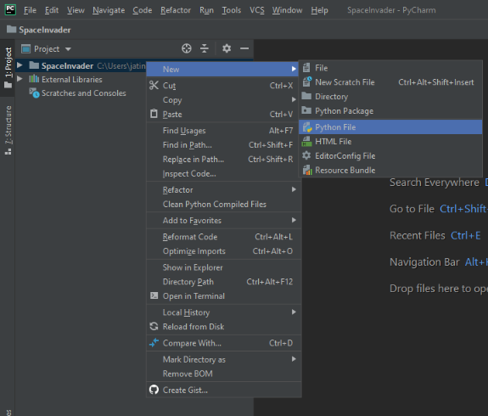

iv) Create **main.py** file .

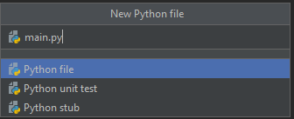

v) Now , Install **pygame package** if it is not installed.

vi) Click on **File** & go-to **Settings.**

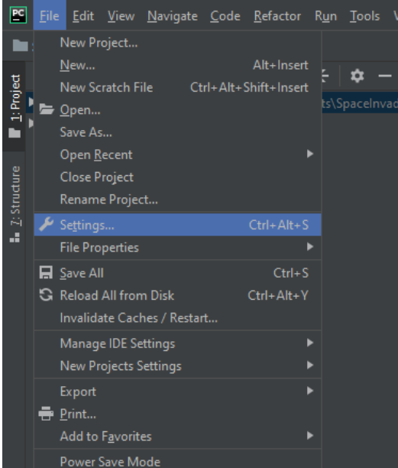

vii) Choose **Python Interpreter** & Click on **‘+’** sign on the right corner.

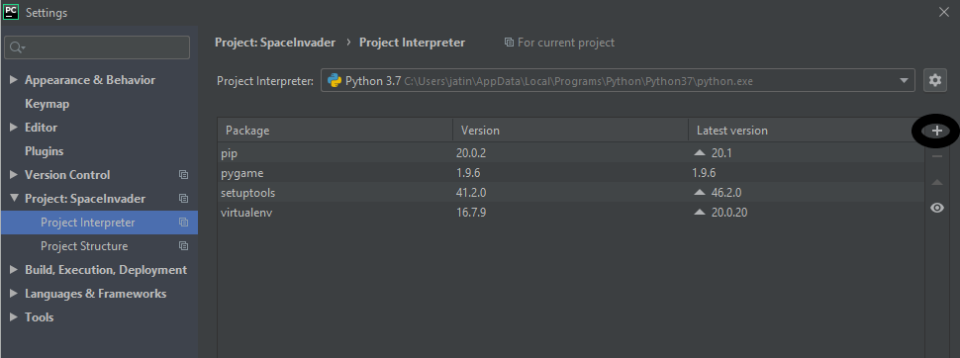

viii) In the search bar , search **pygame** package & click on Install Package.

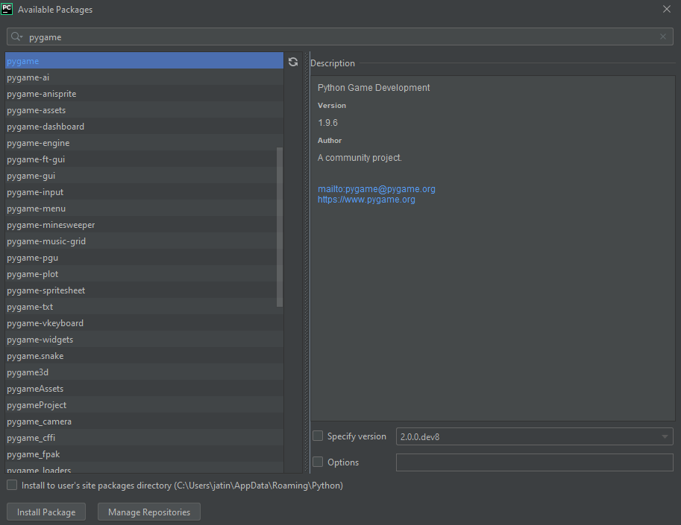

ix) After doing the above steps , write the code from the main.py file provided in the folder .

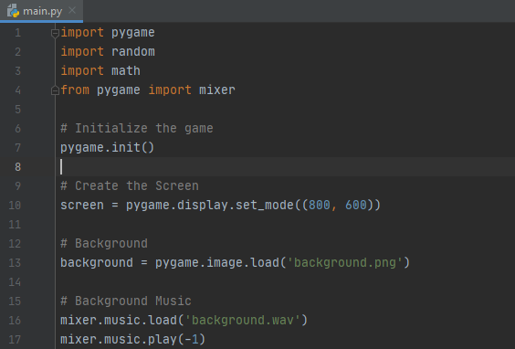

x) Add the png images and sounds from the folder to the **SpaceInvader** folder in your PC so that the code works properly.

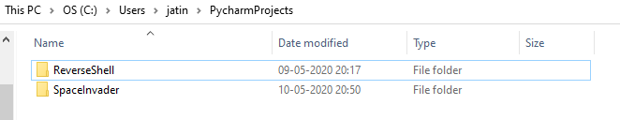

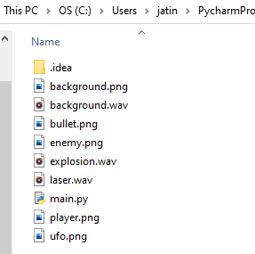

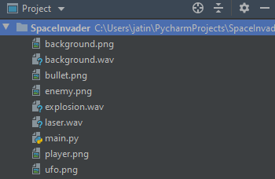

When you Run **main.py** after configuring everything properly, the output will be like as shown below. To control the ship use **Right + Left Arrow** keys & to shoot the invader press **Spacebar** key.

